1. How I downloaded and installed Windows 11.

**Step 1**: I checked my PC's compatibility using the PC Health Check app from Microsoft.

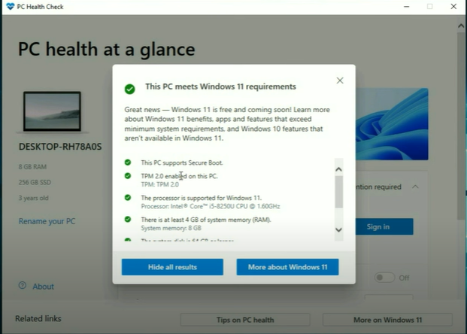

**Step 2:** Before proceeding with the installation, I backed up my important files to avoid any potential data loss.

**Step 3:** Download Windows 11.

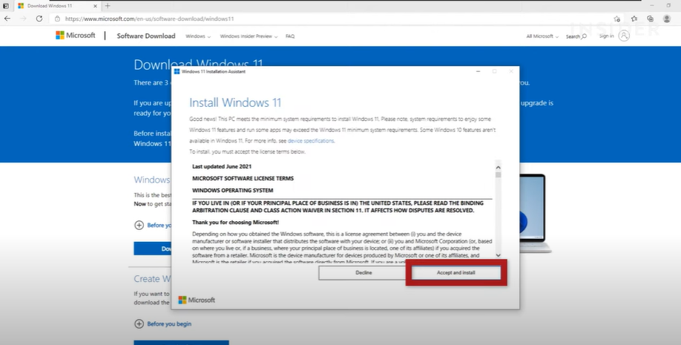

Step 4: I restart my computer

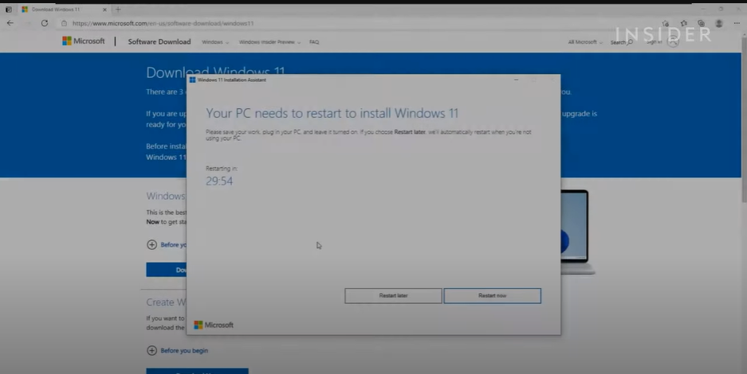

1. How I downloaded and installed Visual Studio.

**Step 1:** Click on the Windows button to download the installer for your operating system.

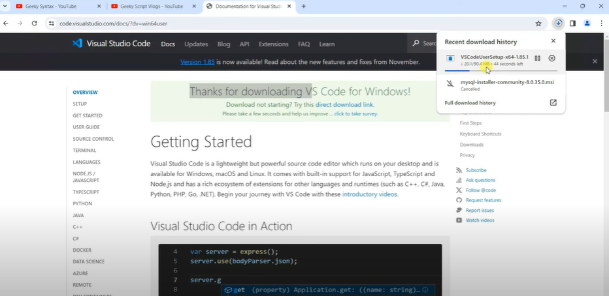

**Step 2:** Install Visual Studio Code

1. Read the license agreement, then check the box to accept the agreement and click Next.

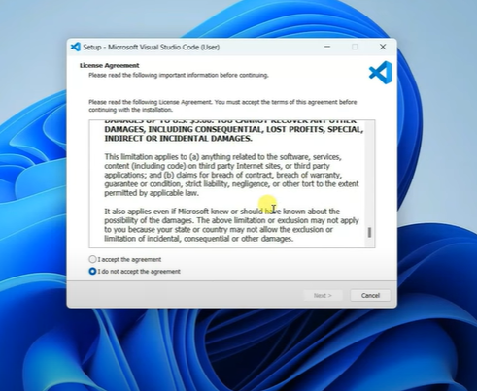

1. Choose the destination folder where you want to install Visual Studio Code.

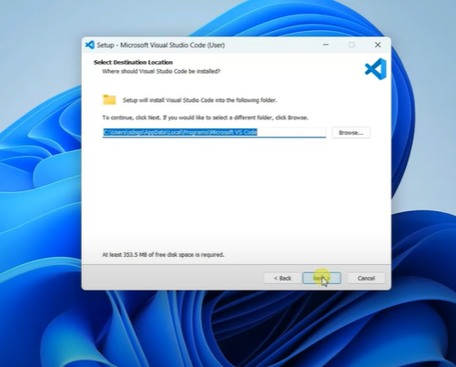

1. Choose the Start Menu folder for the Visual Studio Code shortcuts. The default option is usually fine.

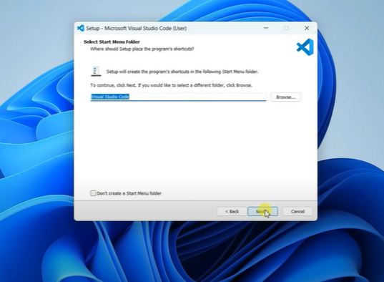

1. Select any additional tasks you would like the installer to perform.

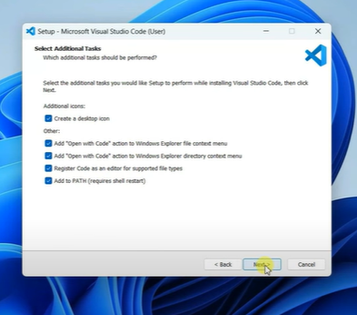

1. Click **Install** to begin the installation.

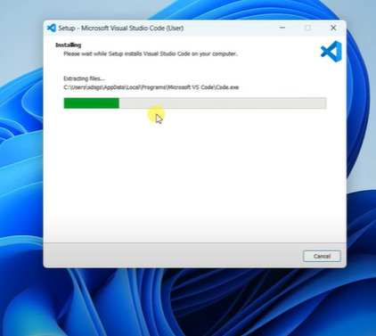

1. I choose to launch Visual Studio Code immediately by checking the box and clicking **Finish**.

**Step 3:** Launch Visual Studio Code

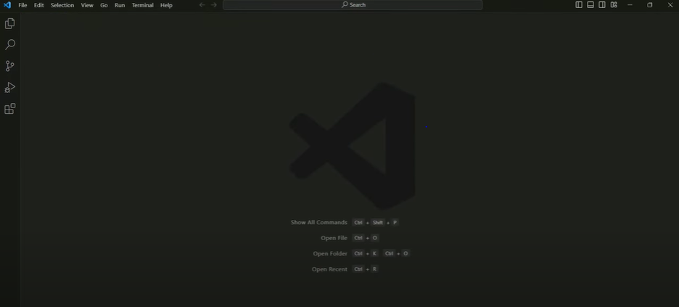

Step 4: Installed extensions like Python and Git.

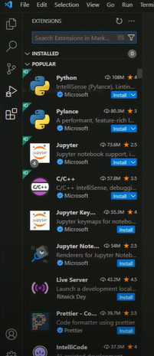

2. How I Set up Git and GitHub

**Step 1**: I installed Git

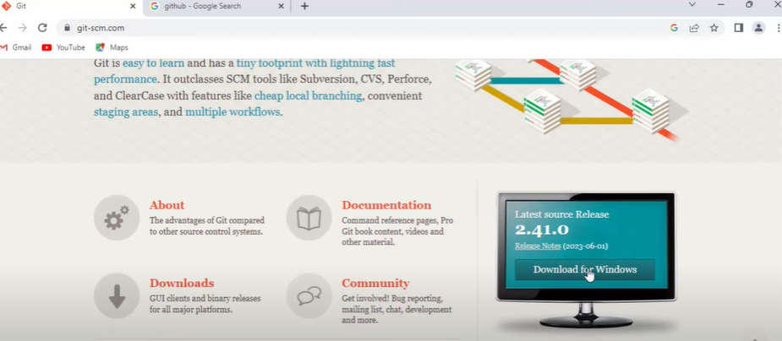

**Step 2:** Run the installer

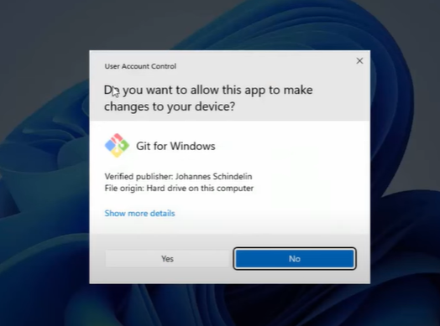

**Step 3:** Set up Wizard.

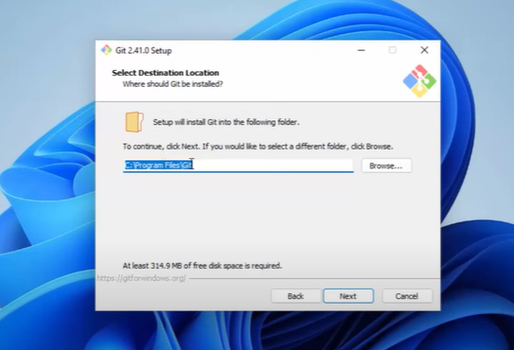

**Step 4:** Default editor to be used by Git

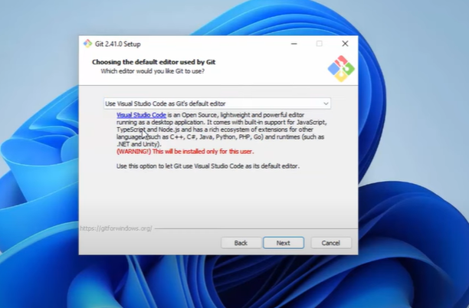

**Step 5:** Adjusting the name of the default initial branch in the new repository

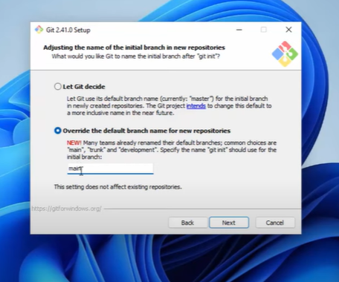

**Step 6:** Adjusting the path environment

**Step 7:** Choosing the SSH Executable.

**Step 8:** Choosing HTTPS transport backend.

**Step 9:** Configuring the line ending conversion.

**Step 10:** Configuring the terminal emulator to use with Git Bash.

**Step 11:** Choose the default behavior of Git pull.

**Step 12:** Click Install to complete the installation process.

**Step 13:** Configure Git

1. Open Git Bash.

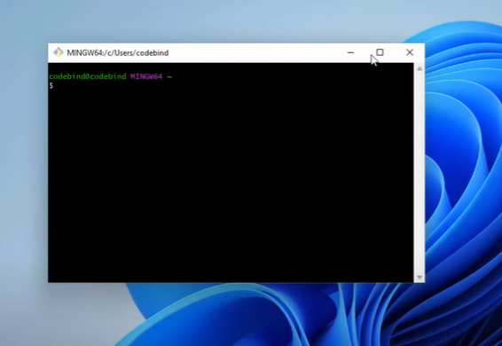

1. Set Username and Email:

git config --global user. name "marywam"

git config --global user.email "maryannewambui0124@gmail.com"

1. Verify Configuration:

git config --list

**Step 14:** Create a Github Account

1. Sign up for GitHub
2. Create your account
3. Verify your Email

**Step 15:** Initialize a git repository

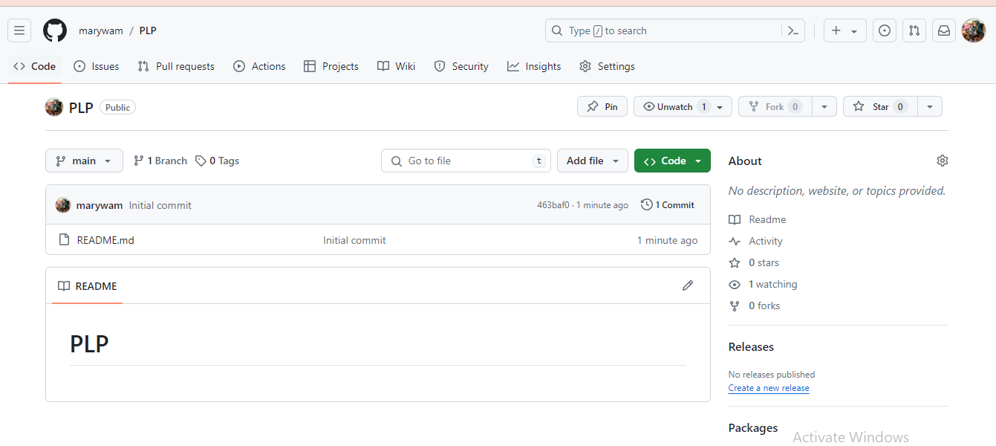

3. How I installed Python for Windows

Step 1: Download the Python installer

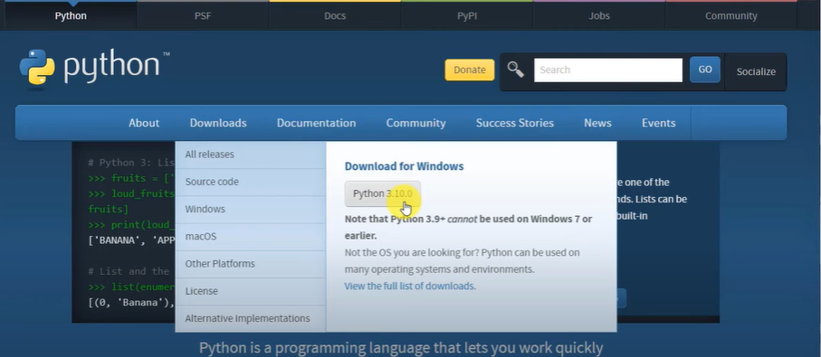

Step 2: Run the installer

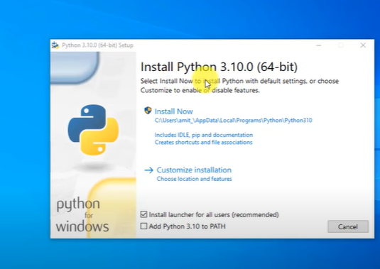

Step 3: Customize installation

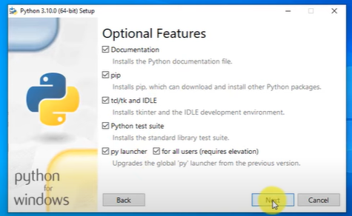

**Step 4:** Advanced options

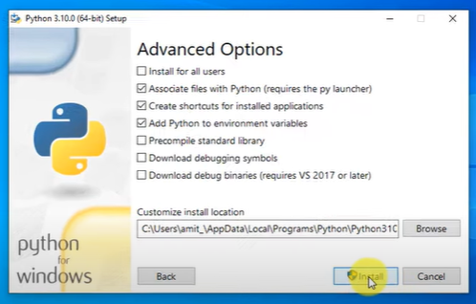

**Step 5:** Complete the installation

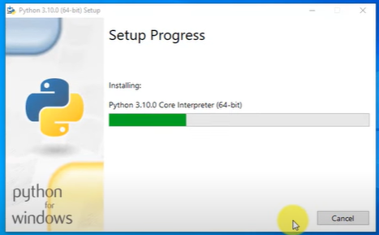

**Step 6:** Open the Command prompt to check the Python version

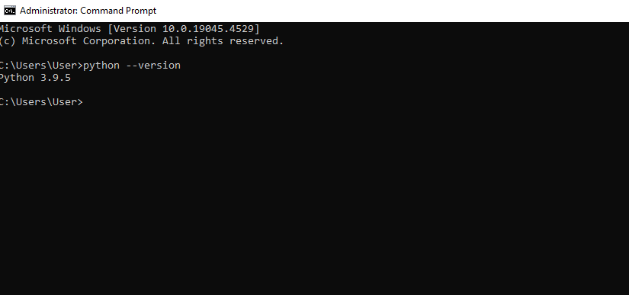

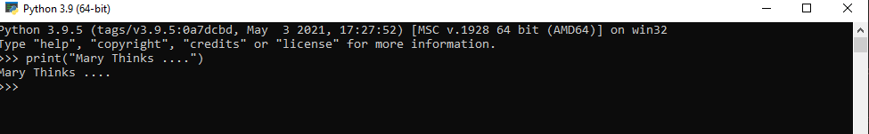

4. Checking the pip version to ensure I have installed

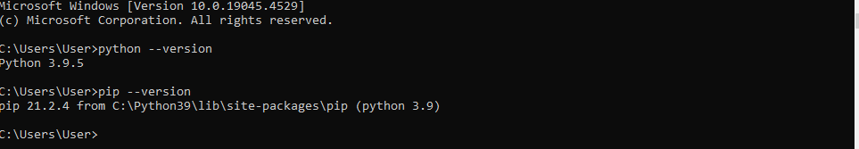

5. Install and configure MYSQL Database on Windows

**Step 1:** Download the installer

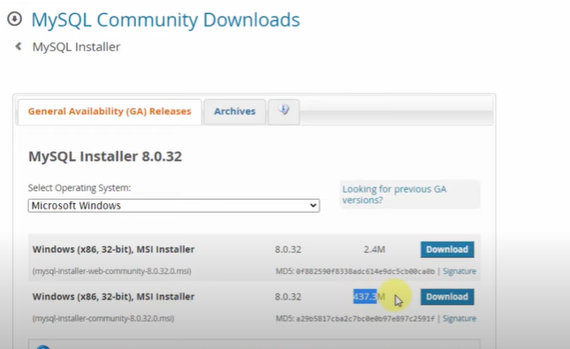

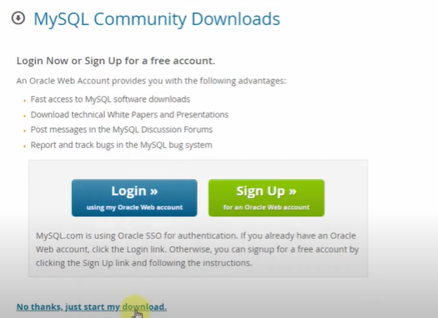

**Step 2:** Install MySQL

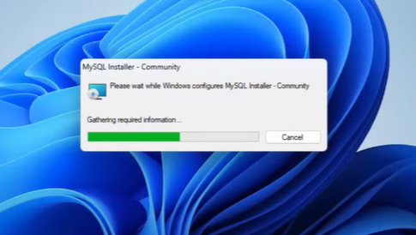

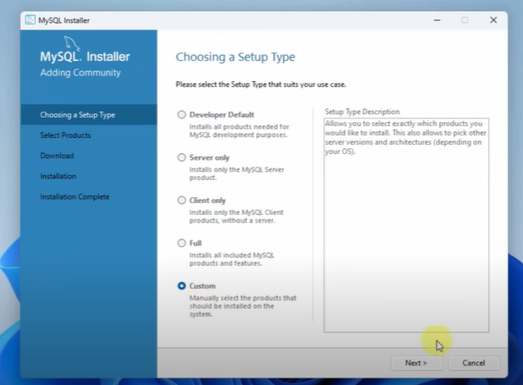

**Step 3:** Check Requirements

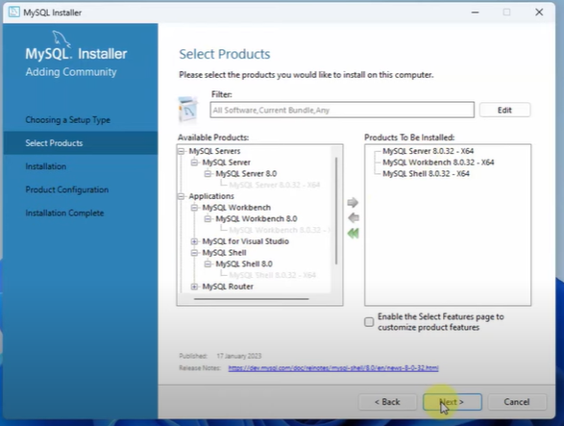

**Step 4:** Installation Process

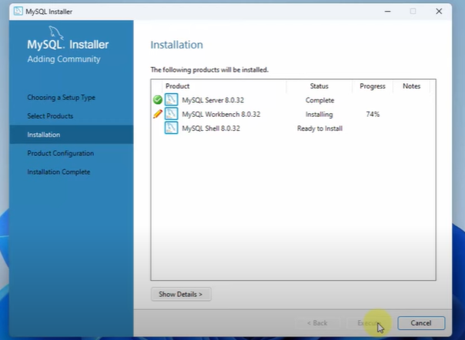

**Step 5:** Configure My SQL Server

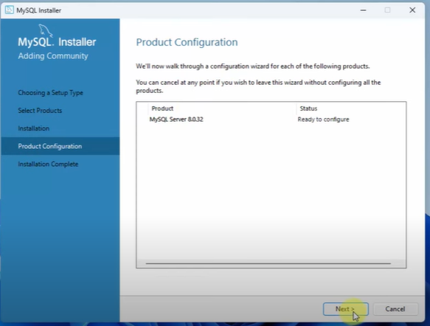

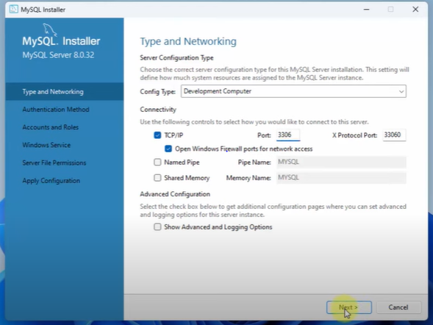

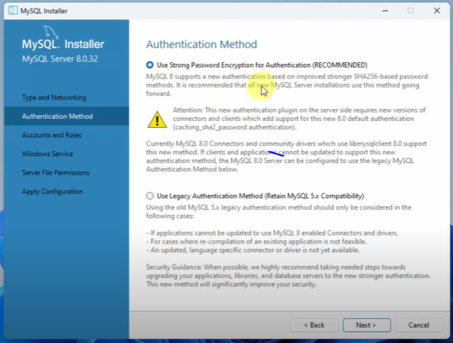

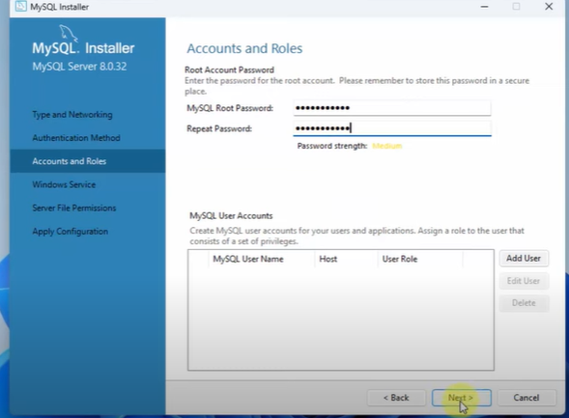

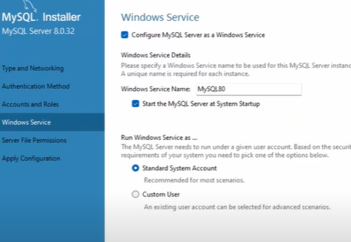

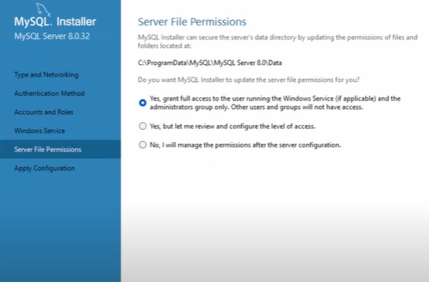

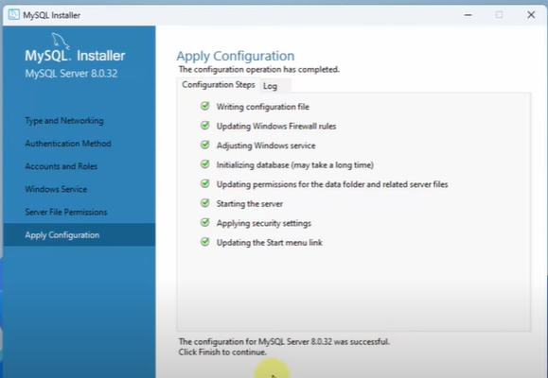

**Step 6:** Verify SQL Installation

**Step 7:** Verify the connection

The challenges faced and solutions

1. Issue: The downloaded installer may be incomplete or corrupted, causing installation errors.

Solution: Ensure you have a stable internet connection and re-download the installer

from the official MySQL website.

1. Issue: The Windows Firewall or other security software might block MySQL server connections.

Solution: Add an exception for MySQL in the Windows Firewall. Go to Control Panel > System and Security > Windows Defender Firewall > Allow an app or feature through Windows Defender Firewall, and then add MySQL.

1. Issue: Misconfiguration during the setup process can lead to issues such as inability to connect to the server.

Solution: Carefully follow the setup instructions, ensuring you choose the correct configuration options. If unsure, use the default settings provided by the installer.